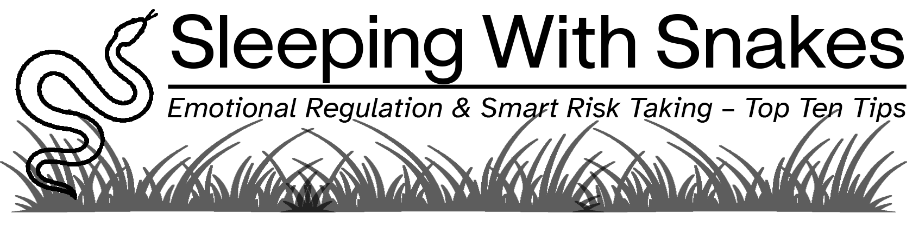

The Core Idea
You do not eliminate risk. You learn to operate alongside it without reacting.

Why Decisions Go Wrong
Under pressure: Stress narrows thinking; emotions override logic and urgency create false clarity.
The Pattern is: React → Justify → Regret

The Advantage
Calm is a performance skill. When you regulate emotions, you make better decisions, lead more effectively, and stay clear under pressure.

The Regulation Loop
Trigger → Emotion → Interpretation → Response
You can’t control every trigger. However, you can interrupt the response.

In-the-Moment Reset
- Name the snake (fear, ego, urgency)
- Name the emotion
- Separate signal vs. story
- Pause before acting

The 90-Second Rule
Emotions peak and pass. Don’t decide at peak emotion.

Reframe the Story
Ask: What else could be true?
Rather than ‘this will fail; think ‘this is an experiment’. Rather than ‘this is a threat’, think this is a challenge.

Smart Risk vs Emotional Risk
Emotional Risk is reactive, fear/ego-driven and only provides short-term relief
Smart Risk is intentional, strategy-aligned and thoughtful

The Smart Risk Filter

Before acting, consider what the upside is and the downside. Determine whether you can survive the downside and whether you are reacting or choosing.

Final Takeaway
The goal isn’t to avoid snakes. It is to stop reacting every time they move.

Provided by Elena Yearly, CEO, EMY Consulting, LLC.

